# Tutorial 2 Document

Sub Group: 19

Bandaru, Sarath Chandra Class ID: 8

Perasani, Akshara Class ID:39

API’s Used:

1. Mashape Text Processing API:

This API processed the input text to tokens and identifies the important features of the sentence like noun phrase, verb phrase, measure of sentence and if the noun is a place then gives its location.

1. Text to Speech :

This API coverts text to speech. In this tutorial the iphone speaks the result.

Project Relevance of the API’s:

* Text processing is one of the key component of natural language processing, which is the main feature in our project. As robot should understand user queries and respond accordingly.
* Text to speech is done when the robot should speak with the user.

ScreenShots:

Figure1:

Console screenshot that shows JSON result after parsing API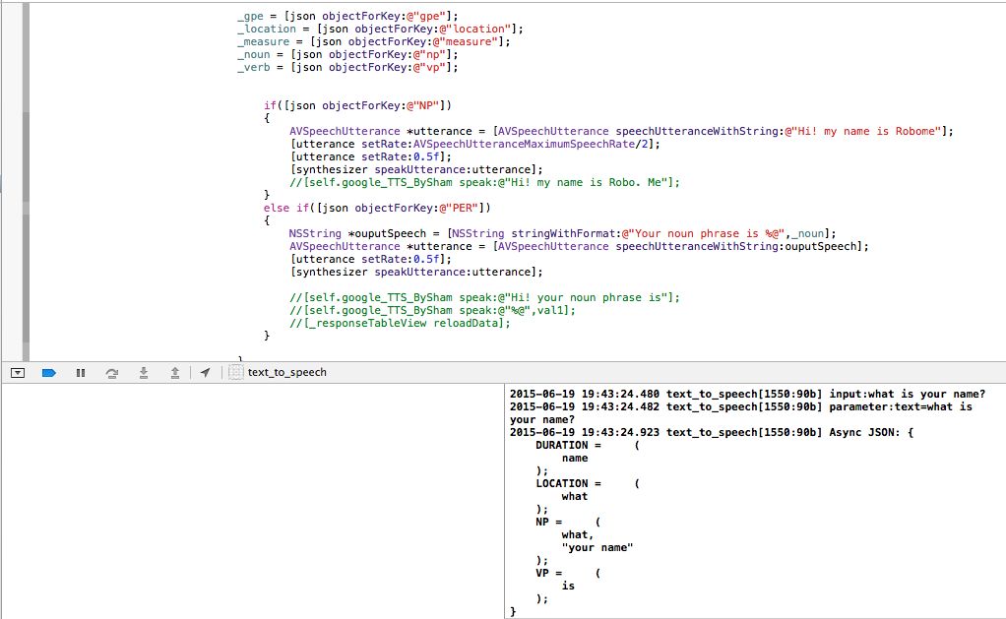

Simulator screenshot that shows speech result 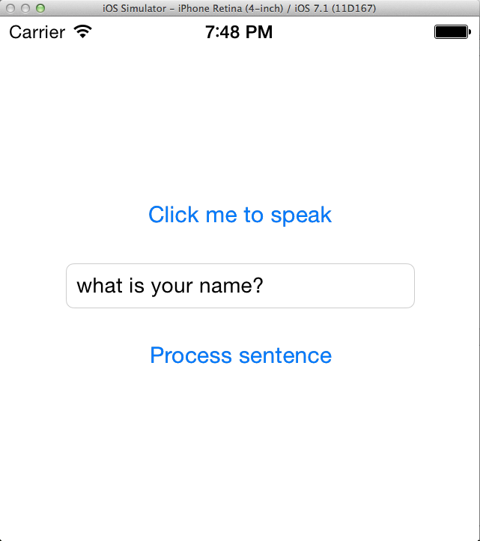

My Name is ROBO-ME